Velocity Profiles: CFD vs Experiment (1200 logs at each point)

|  |  |
| --- | --- |
|  | 5_nolights.png  Figure Line 1 |
| 1_nolights.png  Figure Line 2 | 2_nolights.png  Figure Line 3 |
| 3_nolights.png  Figure Line 4 | 4_nolights.png  Figure Line 5 |

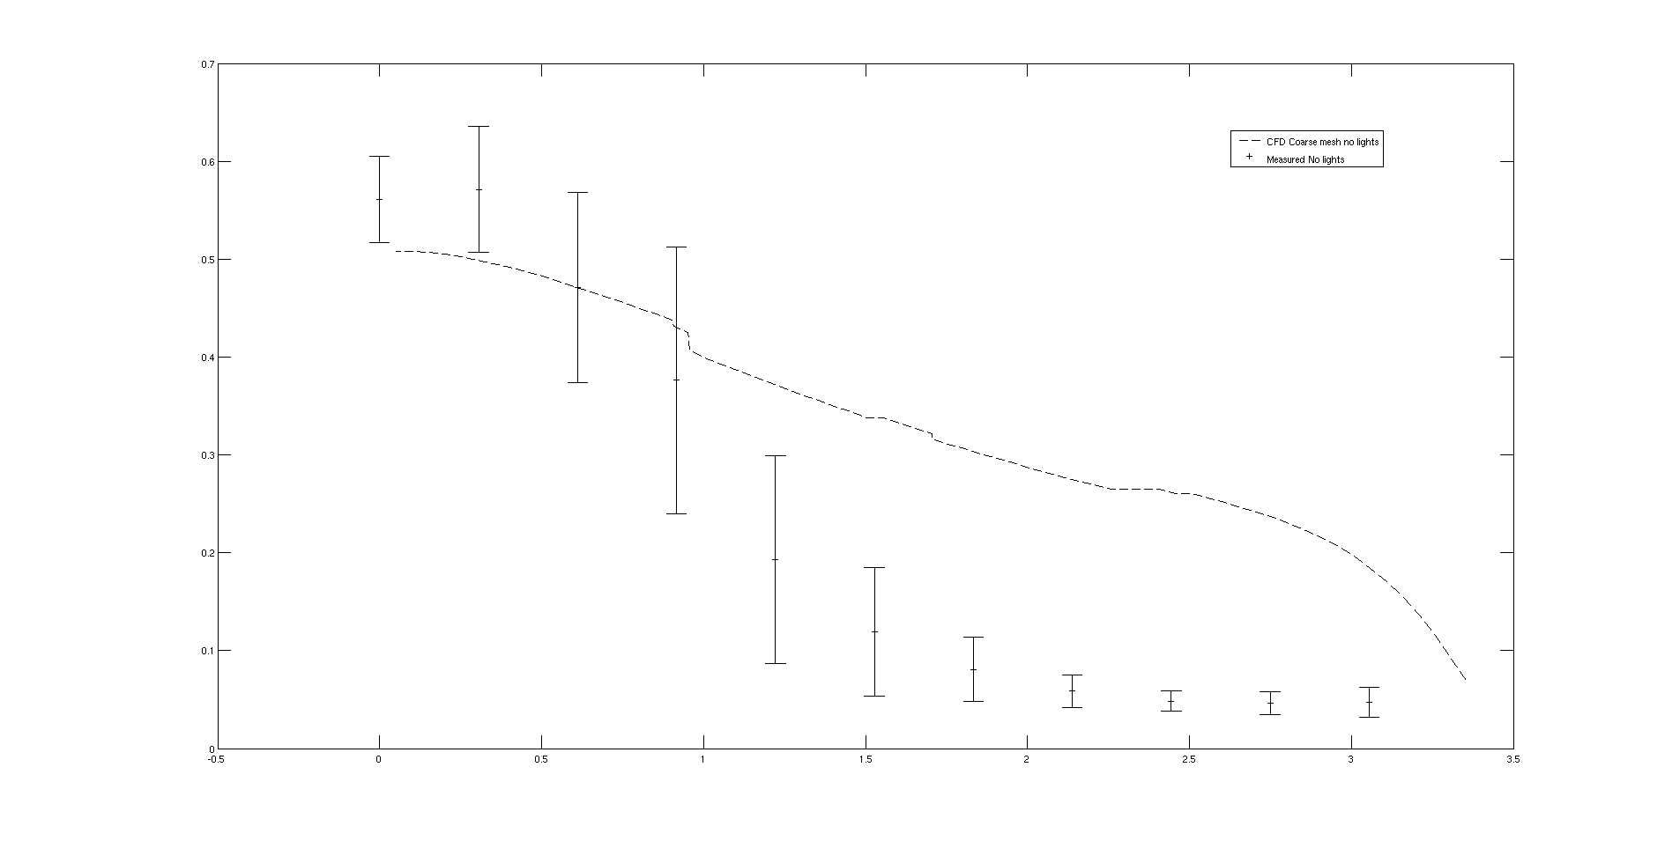

Figure Velocity profile along inlet plane No lights

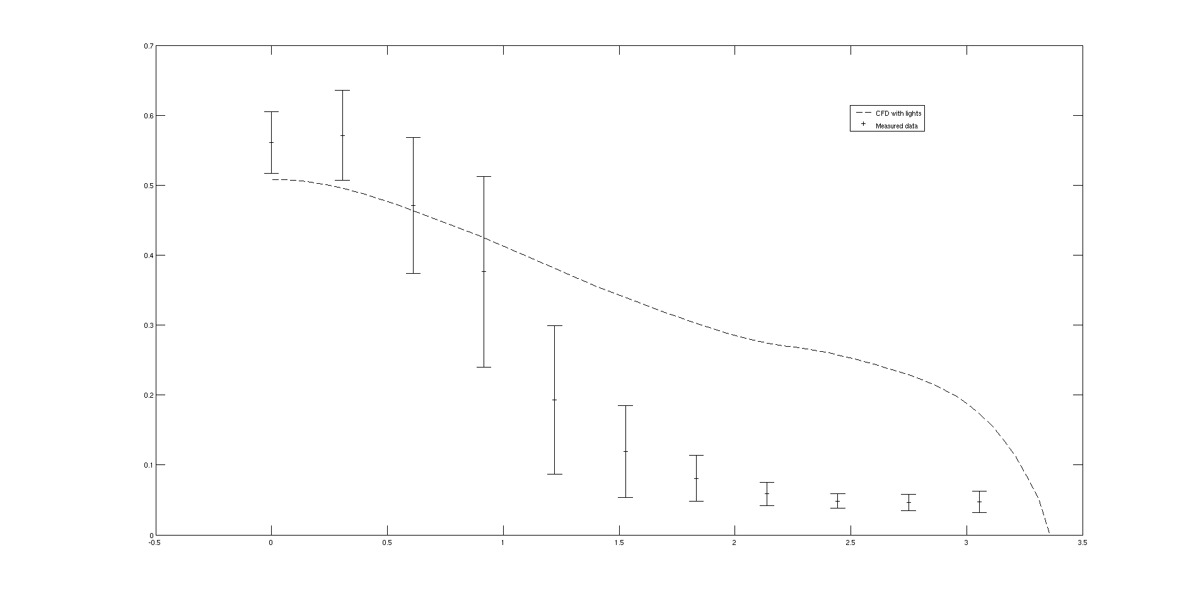

Figure Velocity profile along inlet plane- With lights